

Egypt University of Informatics

Computer and Information Systems

Data Analysis Course

The Analysis of the Performance of Data Analysis Students

Submitted by: Ahmed Sami Abokhalil

29/3/2023

# Introduction

Hey folks! Curious about how study time affects grades? This report's got the scoop! We're exploring student habits to see how hitting the books impacts academic success. Stick around for some eye-opening insights! Let's dive in!

# Research Question

# Survey on Does studying time before the exam affect your grades?

# Hypothesis

# Population of Interest:

Egyptian students

# Sampling Method:

Online collection such as “google forms”

Why?

1. For wider reach.

2. Works well on mobile devices

3. Simple and clear

4. Short and engaging.

# Bias Identification:

# The survey is unbiased due to random sampling, anonymous responses, clear language, inclusive design

# Survey Questions:

1. Gender?

2. Age?

3. How long do you study?

4. How are your grades?

Online survey link: <https://forms.gle/eW6kd5abPzuzNjP77>

Number of samples collected: 30

# Analysis:

Mean:-

Week or more before the exam 85.000000

few days before the exam 82.333333

few hours before the exam 82.142857

Median:-

Week or more before the exam 85.0

few days before the exam 85.0

few hours before the exam 85.0

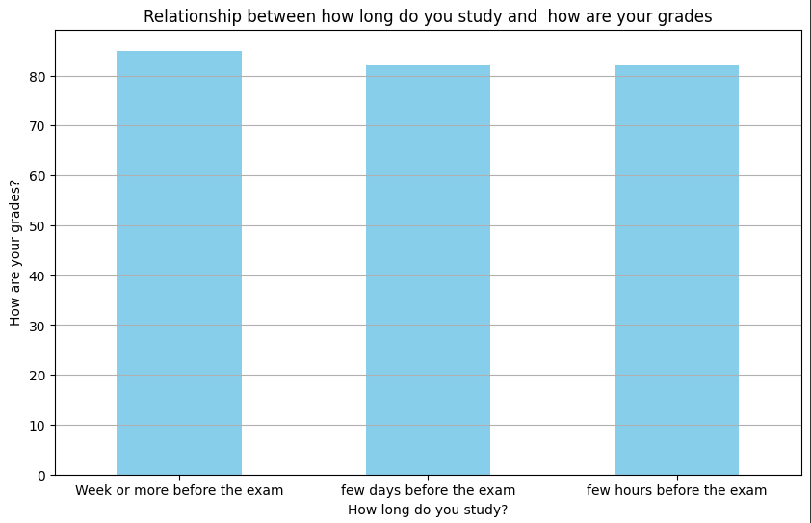Mode=19

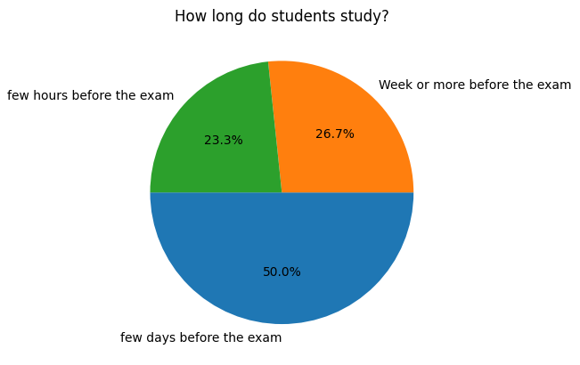

Bar chart showing that all students who studies week or more , few days before or few hours before gets grades 85 as average.

# Conclusion

As a conclusion we can see that studying duration doesn’t affect student’s grades

# Any potential issues

The survey don’t have enough quantitative variables and this could make it hard while finding the correlation or values like mean, median and mode